2lines-eng.xls

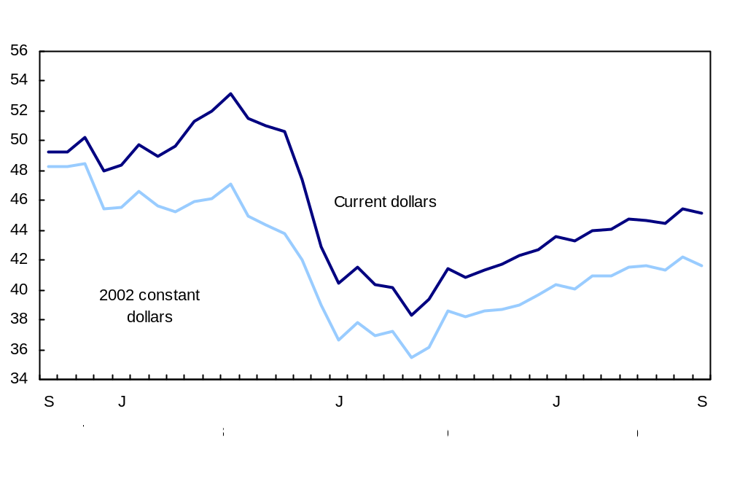

SmartGraph
The title of the graph is "Manufacturing sales decrease in September".
This is a line chart.
There are in total 37 categories in the horizontal axis. The vertical axis starts at 34 and ends at 56 with ticks every 2 points.
There are 2 series in this graph.
The vertical axis is "$ billions¹".
The units of the horizontal axis are months by year ranging from September 2007 to September 2010.
The title of series 1 is "Current dollars".
The minimum value is 38.3 occuring in May 2009.
The maximum value is 53.2 occuring in July 2008.
The title of series 2 is "2002 constant dollars".
The minimum value is 35.492 occuring in May 2009.
The maximum value is 48.487 occuring in November 2007.

cluster-bar-horizontal02-eng.xls

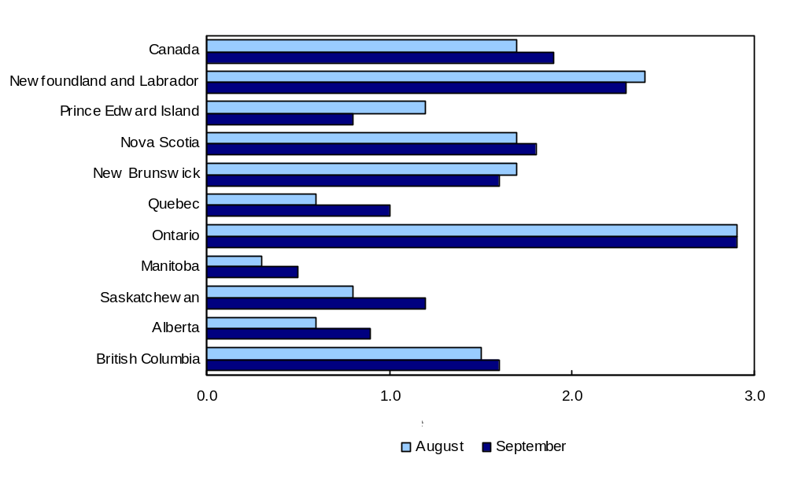
SmartGraph
The title of the graph is "Ontario records the largest year-over-year increase of all provinces in September".
This is a bar clustered chart.
This is a horizontal bar graph, so categories are on the vertical axis and values on the horizontal axis.
There are in total 11 categories in the vertical axis. The horizontal axis starts at 0 and ends at 3 with ticks every 1 points.
There are 2 series in this graph.
The horizontal axis is "12-month % change".
The vertical axis is "unknown".
The title of series 1 is "August".
The minimum value is 0.3 and it corresponds to "Manitoba".
The maximum value is 2.9 and it corresponds to "Ontario".
The title of series 2 is "September".
The minimum value is 0.5 and it corresponds to "Manitoba".
The maximum value is 2.9 and it corresponds to "Ontario".
cluster-bar-horizontal-eng.xls

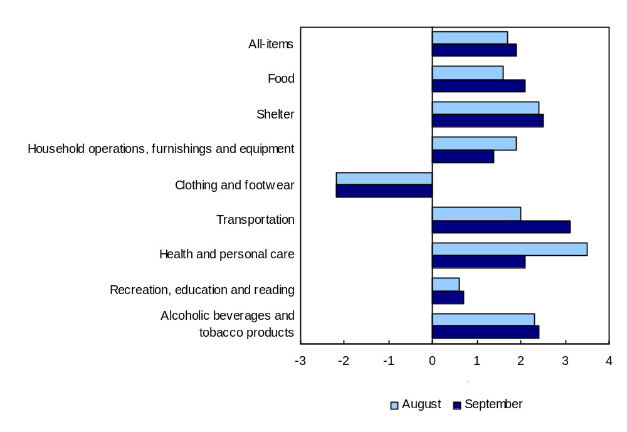
SmartGraph
The title of the graph is "Prices up in seven of eight major components".
This is a bar clustered chart.
This is a horizontal bar graph, so categories are on the vertical axis and values on the horizontal axis.
There are in total 9 categories in the vertical axis. The horizontal axis starts at -3 and ends at 4 with ticks every 1 points.
There are 2 series in this graph.
The horizontal axis is "12-month % change".
The vertical axis is "unknown".
The title of series 1 is "August".
The minimum value is -2.2 and it corresponds to "Clothing and footwear".
The maximum value is 3.5 and it corresponds to "Health and personal care".
The title of series 2 is "September".
The minimum value is -2.2 and it corresponds to "Clothing and footwear".
The maximum value is 3.1 and it corresponds to "Transportation".

cluster-bar-monthly-eng.xls

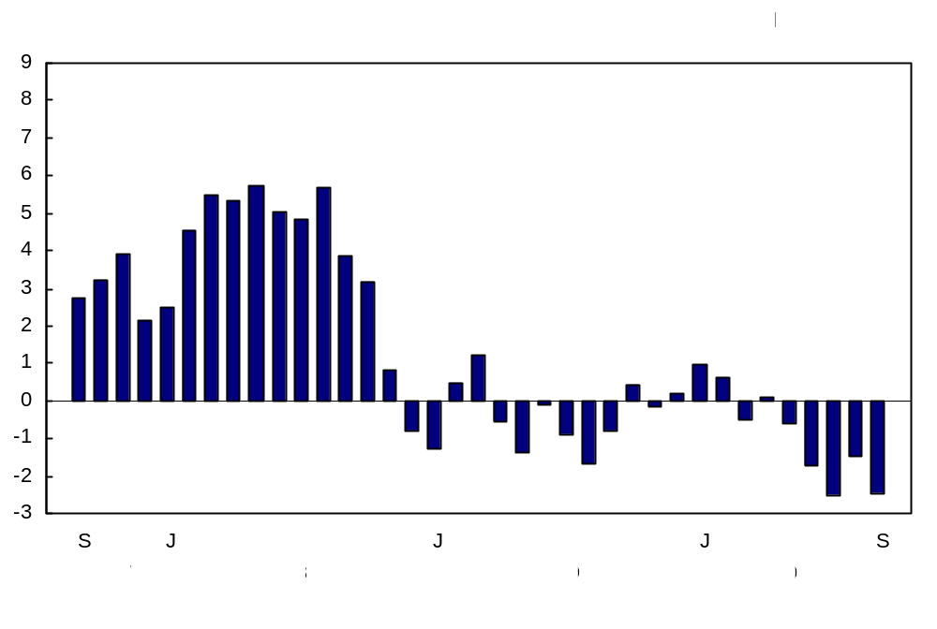
SmartGraph
The title of the graph is "Trade balance".
This is a column clustered chart.
There are in total 37 categories in the horizontal axis. The vertical axis starts at -3 and ends at 9 with ticks every 1 points.
There are 1 series in this graph.
The vertical axis is "billions of dollars, seasonally adjusted".
The units of the horizontal axis are months by year ranging from September 2007 to September 2010.
The title of series 1 is unknown.
The minimum value is -2.511 occuring in July 2010.
The maximum value is 5.723 occuring in May 2008.

cluster-bar-quarters-eng.xls

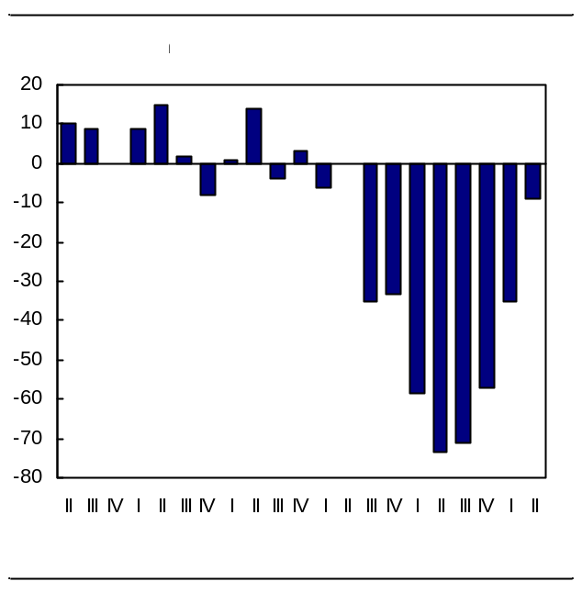
SmartGraph
The title of the graph is "Balance of opinion of expected occupancy rates".
This is a column clustered chart.
There are in total 21 categories in the horizontal axis. The vertical axis starts at -80 and ends at 20 with ticks every 10 points.
There are 1 series in this graph.
The vertical axis is "balance of opinion".
The units of the horizontal axis are quarters by year ranging from second quarter 2005 to second quarter 2010.
The title of series 1 is unknown.
The minimum value is -73.6 occuring in second quarter 2009.
The maximum value is 15 occuring in second quarter 2006.

cluster-bar-with-values-eng.xls

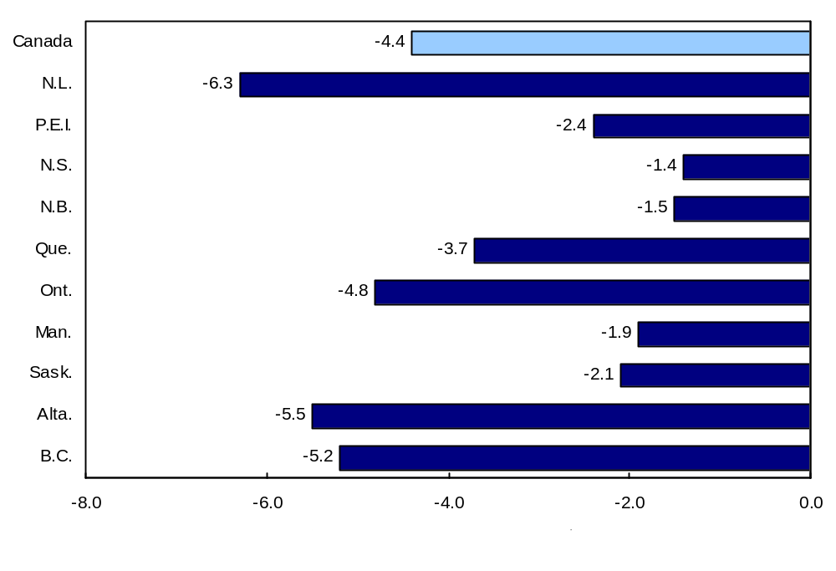
SmartGraph
The title of the graph is "Hours worked in the business sector by province, 2009 ".
This is a bar clustered chart.
This is a horizontal bar graph, so categories are on the vertical axis and values on the horizontal axis.
There are in total 11 categories in the vertical axis. The horizontal axis starts at -8 and ends at 0 with ticks every 2 points.
There are 1 series in this graph.
The horizontal axis is "% change from the previous year".
The vertical axis is "unknown".
The title of series 1 is unknown.
The minimum value is -6.3 and it corresponds to "N.L.".
The maximum value is -1.4 and it corresponds to "N.S.".
cluster-column-eng.xls

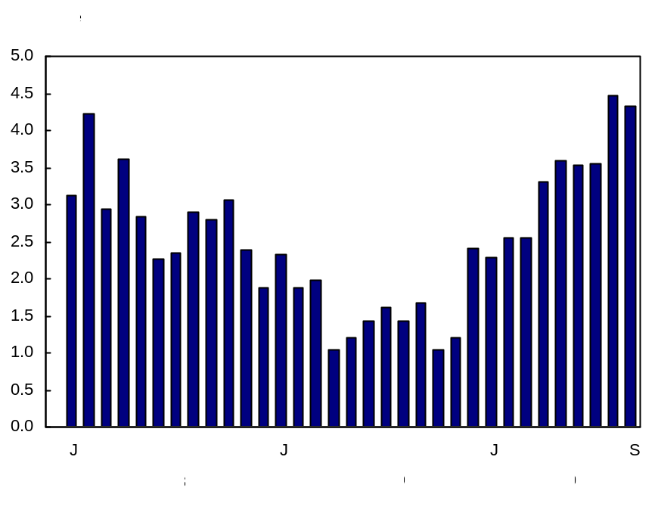
SmartGraph
The title of the graph is "The 12-month change in average weekly earnings".
This is a column clustered chart.
There are in total 33 categories in the horizontal axis. The vertical axis starts at 0 and ends at 5 with ticks every 0.5 points.
There are 1 series in this graph.
The vertical axis is "% change".
The units of the horizontal axis are months by year ranging from January 2008 to September 2010.
The title of series 1 is "The 12-month change in average weekly earnings 0.00".
The minimum value is 1.04477247177282 occuring in October 2009.
The maximum value is 4.46062371071472 occuring in August 2010.

cluster-column-line-markers-eng.xls

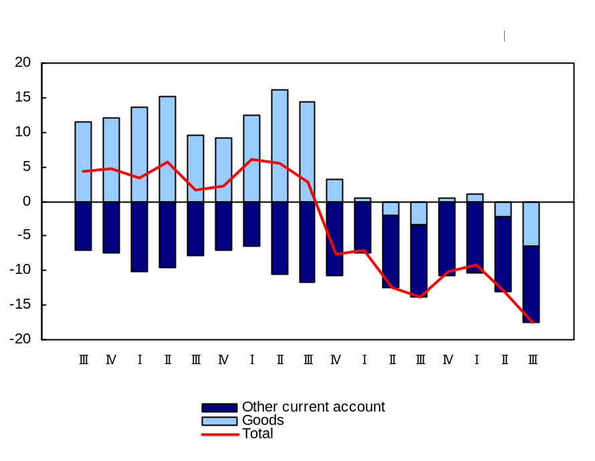
SmartGraph

The title of the graph is "Current account balances".
This is a combined line chart.
There are in total 17 categories in the horizontal axis. The vertical axis starts at -20 and ends at 20 with ticks every 5 points.
There are 3 series in this graph.
The vertical axis is "billions of dollars, Seasonally adjusted".
The units of the horizontal axis are quarters by year ranging from third quarter 2006 to third quarter 2010.
The title of series 1 is "Goods".
This series is a column stacked chart.
The minimum value is -6.504 occuring in third quarter 2010.
The maximum value is 16.095 occuring in second quarter 2008.
The title of series 2 is "Other current account".
This series is a column stacked chart.
The minimum value is -11.603 occuring in third quarter 2008.
The maximum value is -6.387 occuring in first quarter 2008.
The title of series 3 is "Total".
This series is a line chart.
The minimum value is -17.536 occuring in third quarter 2010.
The maximum value is 6.164 occuring in first quarter 2008.

cluster-column-with-values-eng.xls

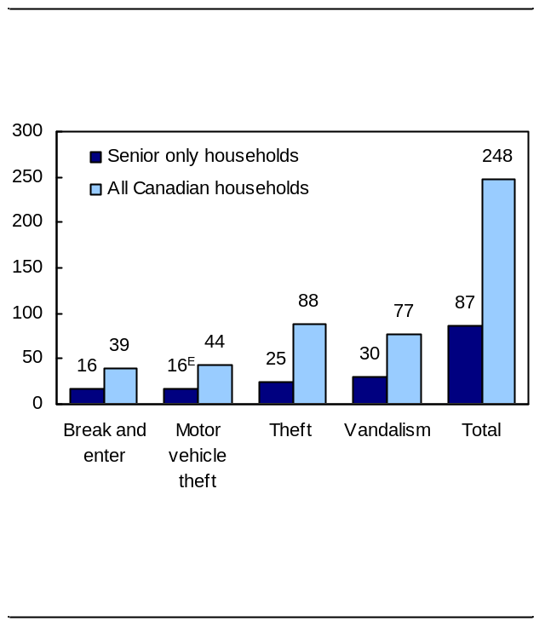

SmartGraph
The title of the graph is "Senior households nearly three times less likely to be victimized, 2004".
This is a column clustered chart.
There are in total 5 categories in the horizontal axis. The vertical axis starts at 0 and ends at 300 with ticks every 50 points.
There are 2 series in this graph.
The vertical axis is "Senior households1 nearly three times less likely to be victimized, 2004, rate per 1,000 households".
The horizontal axis is "E use with caution1. Based on those households consisting of residents 65 years and older. Household property crimes include attempted and actual incidents.".
The title of series 1 is "Senior only households".
The minimum value is 16 and it corresponds to "Break and enter and Motor vehicle theft".
The maximum value is 87 and it corresponds to "Total".
The title of series 2 is "All Canadian households".
The minimum value is 39 and it corresponds to "Break and enter".
The maximum value is 248 and it corresponds to "Total".
column-and-line-eng.xls

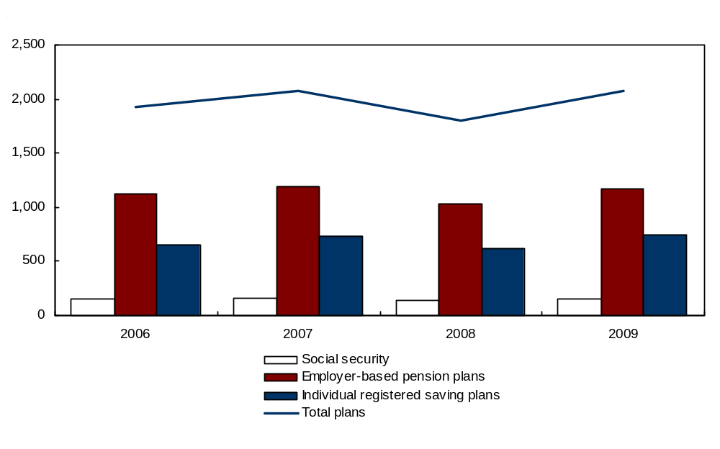
SmartGraph
The title of the graph is "Assets of Canada's pension system, at market value".
This is a combined line chart.
There are in total 4 categories in the horizontal axis. The vertical axis starts at 0 and ends at 2,500 with ticks every 500 points.
There are 4 series in this graph.
The vertical axis is "$ billions".
The units of the horizontal axis are years ranging from 2006 to 2009.
The title of series 1 is "Social security".
This series is a column clustered chart.
The minimum value is 136.607 occuring in 2008.
The maximum value is 157.804 occuring in 2007.
The title of series 2 is "Employer-based pension plans".
This series is a column clustered chart.
The minimum value is 1,035.026 occuring in 2008.
The maximum value is 1,186.954 occuring in 2007.
The title of series 3 is "Individual registered saving plans".
This series is a column clustered chart.
The minimum value is 623.249 occuring in 2008.
The maximum value is 750.929 occuring in 2009.
The title of series 4 is "Total plans".
This series is a line chart.
The minimum value is 1,794.882 occuring in 2008.
The maximum value is 2,080.909 occuring in 2007.
column-eng.xls

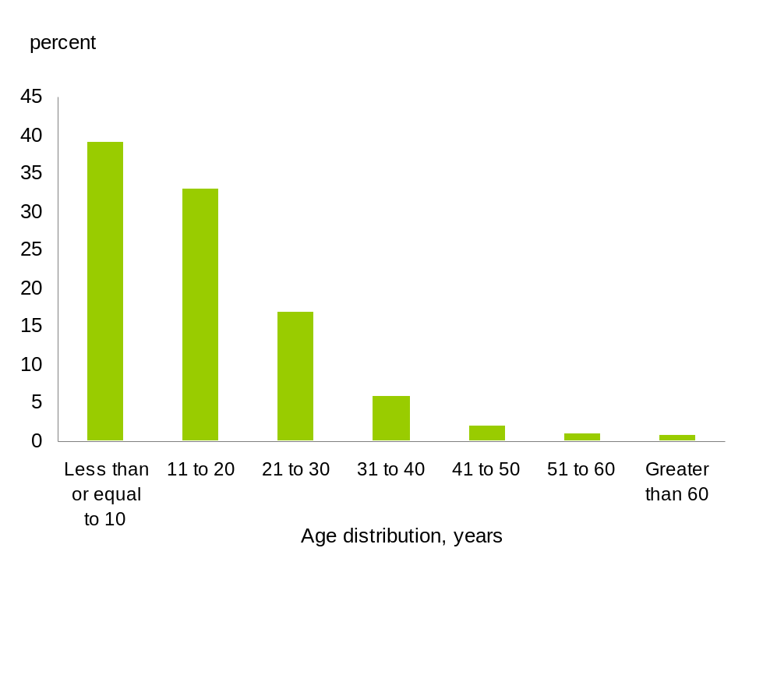
SmartGraph
The title of the graph is " Age distribution of retail gas stations across Canada, 2009".
This is a column clustered chart.
There are in total 7 categories in the horizontal axis. The vertical axis starts at 0 and ends at 45 with ticks every 5 points.
There are 1 series in this graph.
The vertical axis is "percent ".
The horizontal axis is "Age distribution, years".
The title of series 1 is "Series1".
The minimum value is 0.8 and it corresponds to "Greater than 60".
The maximum value is 39 and it corresponds to "Less than or equal to 10 ".
This chart has a note which reads "Source(s): Statistics Canada, Environment Accounts and Statistics Division.".
cpi-line-with-zero-as-line-eng.xls

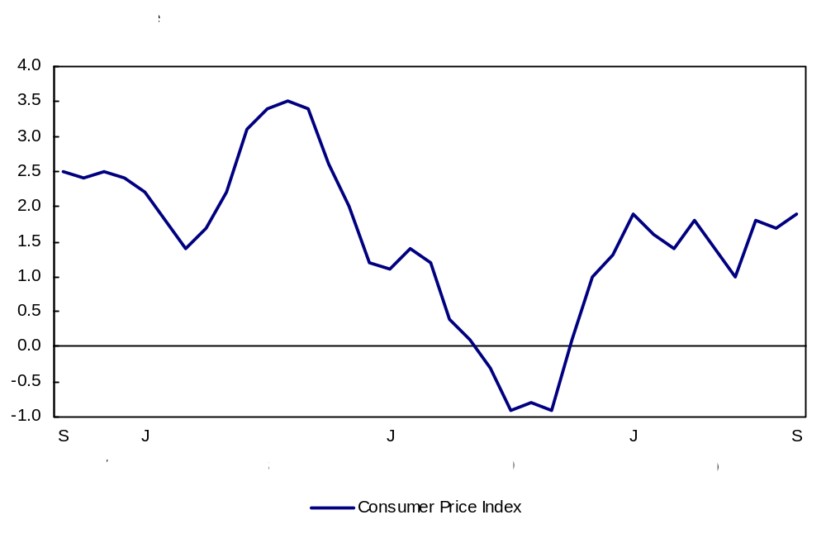
SmartGraph

The title of the graph is "The 12-month change in the Consumer Price Index".
This is a line chart.
There are in total 37 categories in the horizontal axis. The vertical axis starts at -1 and ends at 4 with ticks every 0.5 points.
There are 1 series in this graph.
The vertical axis is "12-month % change".
The units of the horizontal axis are months by year ranging from September 2007 to September 2010.
The title of series 1 is "Consumer Price Index".
The minimum value is -0.9 occuring in July 2009 and September 2009.
The maximum value is 3.5 occuring in August 2008.

line-and-bar-eng.xls
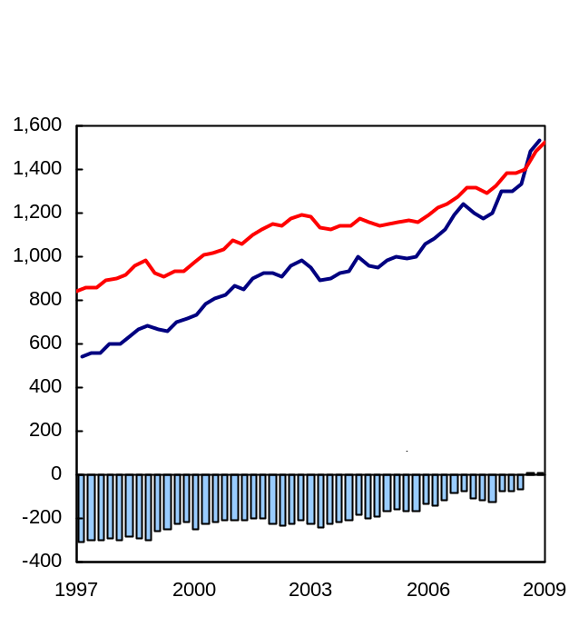

SmartGraph
The title of the graph is "Canada's international investment position".
This is a combined line chart.
There are in total 49 categories in the horizontal axis. The vertical axis starts at -400 and ends at 1,600 with ticks every 200 points.
There are 3 series in this graph.
The vertical axis is "$ billions".
The units of the horizontal axis are years ranging from first quarter 1997 to first quarter 2009.
The title of series 1 is "Net international investment position".
This series is a column clustered chart.
The minimum value is -307.598 occuring in first quarter 1997.
The maximum value is 10.0650000000001 occuring in first quarter 2009.
The title of series 2 is "Total Assets".
This series is a line chart.
The minimum value is 537.937 occuring in first quarter 1997.
The maximum value is 1,532.779 occuring in first quarter 2009.
The title of series 3 is "Total Liabilities".
This series is a line chart.
The minimum value is 845.535 occuring in first quarter 1997.
The maximum value is 1,522.714 occuring in first quarter 2009.
This chart has a note which reads "Total assets".
This chart has a note which reads "Net international investment position".
line-and-scatter-eng.xls
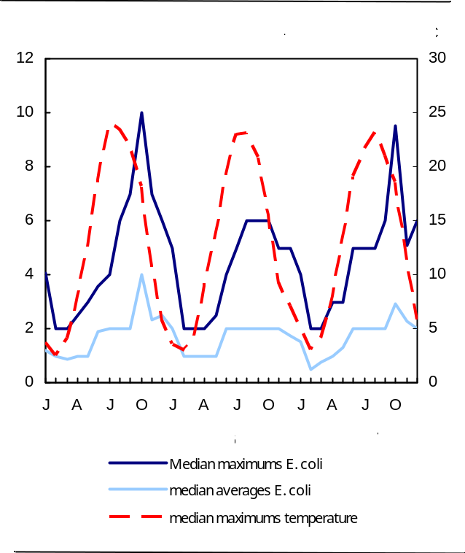

SmartGraph
The title of the graph is "Seasonal variations in E. coli bacteria and temperature in untreated source water, raw surface water, 2005 to 2007 ".
This is a line chart.
There are in total 36 categories in the horizontal axis. The primary vertical axis starts at 0 and ends at 12 with ticks every 2 points. The secondary vertical axis starts at 0 and ends at 30 with ticks every 5 points.
There are 3 series in this graph.
The units of the horizontal axis are months by year ranging from January 2005 to December 2007.
The title of series 1 is "Median maximums E. coli".
The vertical axis is "colony forming units (CFU) per 100 mL".
The minimum value is 2 occuring in February 2005, March 2005, February 2006, March 2006, April 2006, February 2007 and March 2007.
The maximum value is 10 occuring in October 2005.
The title of series 2 is "median averages E. coli".
The vertical axis is "colony forming units (CFU) per 100 mL".
The minimum value is 0.5 occuring in February 2007.
The maximum value is 4 occuring in October 2005.
The title of series 3 is "median maximums temperature".
The vertical axis is "oC".
The minimum value is 2.5 occuring in February 2005.
The maximum value is 24 occuring in July 2005.
line-eng.xls
SmartGraph
The title of the graph is "The 12-month change in the Consumer Price Index".
This is a line chart.
There are in total 37 categories in the horizontal axis. The vertical axis starts at -1 and ends at 4 with ticks every 0.5 points.
There are 1 series in this graph.
The vertical axis is "12-month % change".
The units of the horizontal axis are months by year ranging from September 2007 to September 2010.
The title of series 1 is "Consumer Price Index".
The minimum value is -0.9 occuring in July 2009 and September 2009.
The maximum value is 3.5 occuring in August 2008.
stacked-column-eng.xls
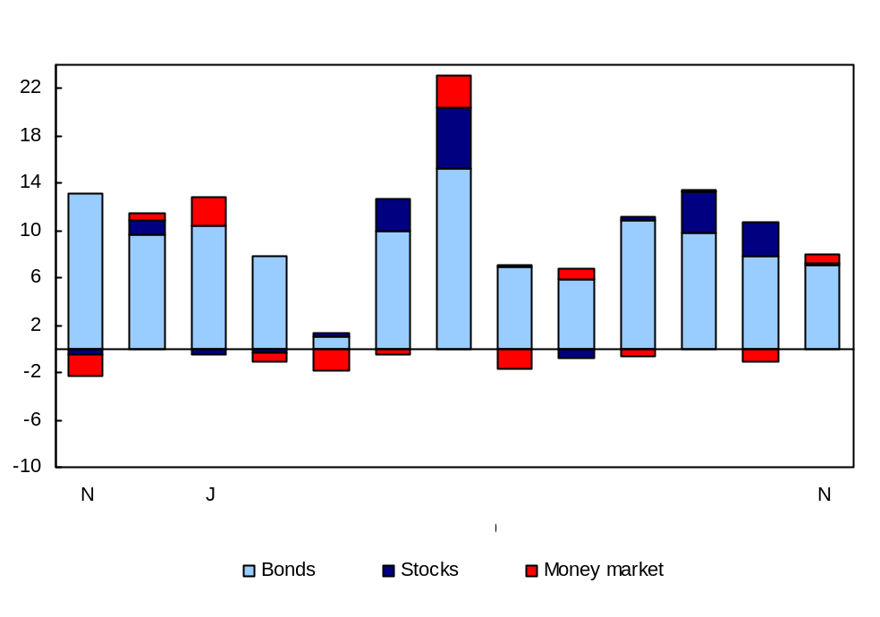
SmartGraph
The title of the graph is "Foreign portfolio investment in Canadian securities".
This is a column stacked chart.
There are in total 13 categories in the horizontal axis. The vertical axis starts at -10 and ends at 24 with ticks every 4 points.
There are 3 series in this graph.
The vertical axis is "billions of dollars".
The units of the horizontal axis are months by year ranging from November 2009 to November 2010.
The title of series 1 is "Bonds".
The minimum value is 0.982 occuring in March 2010.
The maximum value is 15.221 occuring in May 2010.
The title of series 2 is "Stocks".
The minimum value is -0.728 occuring in July 2010.
The maximum value is 5.158 occuring in May 2010.
The title of series 3 is "Money market".
The minimum value is -1.902 occuring in November 2009.
The maximum value is 2.662 occuring in May 2010.

